Lab work review:

The whole lab work I have been done since my undergraduate has a final goal: to understand cancer, to find a true way to treat cancer, and find the truth of nature.

There are five stages since the undergraduate: the first stage is in Pro. Wang’s lab. In this stage, I was looking for the understanding of biomedical science in mechanical and engineering ways. During this period, I finished about 7 patents, one internship and several lab projects. The second stage is IGEM competition. I was looking for the innovative modification and creation from genetic levels in synthetic biological field. During this period, I led my team win the silver award of IGEM with three genetic projects. The third stage is in Pro. Feng’s lab, in which the undergraduate thesis was the main job. In this stage, I was looking for the understanding of cancer (Esophageal cancer) from biomedical engineering and clinical view. During that time, I worked hard mainly in hospital with X-ray CT physicians to find better mathematical method to identify the esophageal cancer. The fourth stage is in Pro. Entcheva’s lab in Stonybrook University about Optogenetics. During that period, I was looking for the possibility of using Optogentical ways to detect the cancer in cellular ways because Optogenetics could be very precise took for detection in cellular level. The fifth stage is in current lab, Pro. Balaji ‘s lab, which engaging in nanotechnology. I was trying my best in mainly two directions: one is to study the mechanism of contrast agents in MRI in detection cancer; another is to improve the nanoparticles (biocompatibility and degradation in vivo) as the drug delivery method targeted at cancer. During that period (last semester), I mainly use statistical and mathematical method and programming strategy to study the theoretical mechanism. The whole lab experiences are around the cancer but from different view, even different field.

Cancer is a key for aging problem as well as health problems. It is so complex that in order to understand it, I have to study from different fields. However, the mechanism is still unclear. For several decades of study cancer, people have gained a lot of knowledge about it, but the treatment is still not perfect. I believe it is my duty to renew approaches and final treatment for cancer.

Techniques:

Matlab:

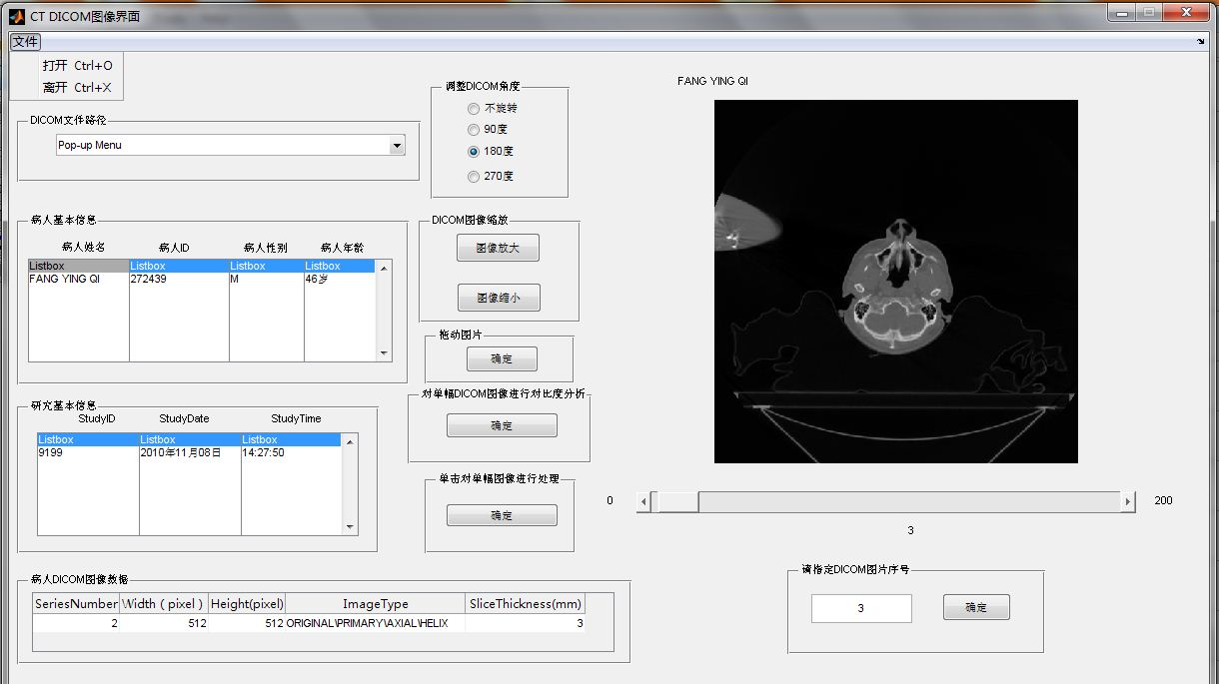

This is a platform for Esophageal cancer CT diagnose in hospitals, which is developed by myself. For details, please see Pro. Feng’s lab in Lab work item.

Java:

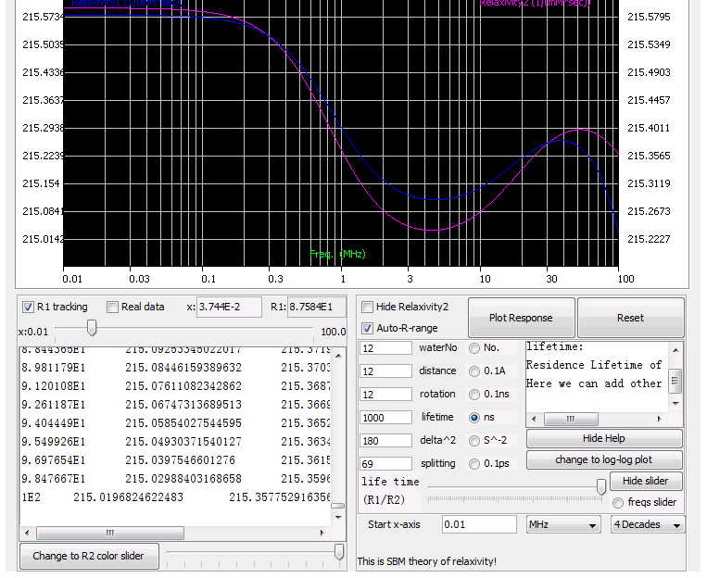

This is a simulation platform for the relaxivity mechanism of contrast agents in MRI for cancer diagnose, which is developed by myself. For details, please see Pro. Balaji’s lab in Lab work item.

Python (one popular language):

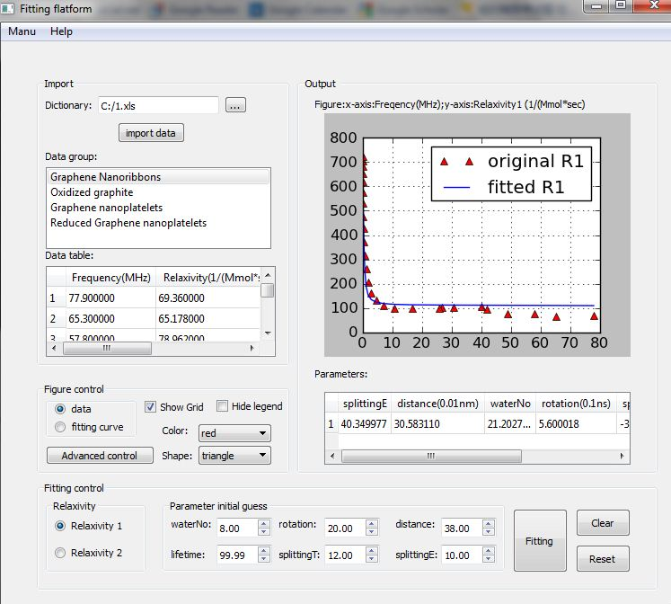

This is a fitting platform for the relaxivity mechanism of contrast agents in MRI for cancer diagnose, which is developed by myself. For details, please see Pro. Balaji’s lab in Lab work item.

SPSS (Statistical Package for Social Sciences software)

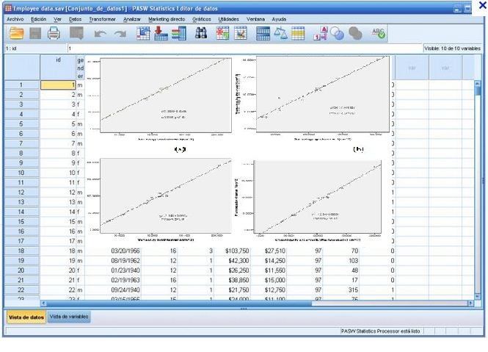

This is the work process using SPSS when I was studying the mechanism of CT diagnose for Esophageal cancer. For details, please see Pro. Feng’s lab in Lab work item.

AutoCAD (mechanical software)

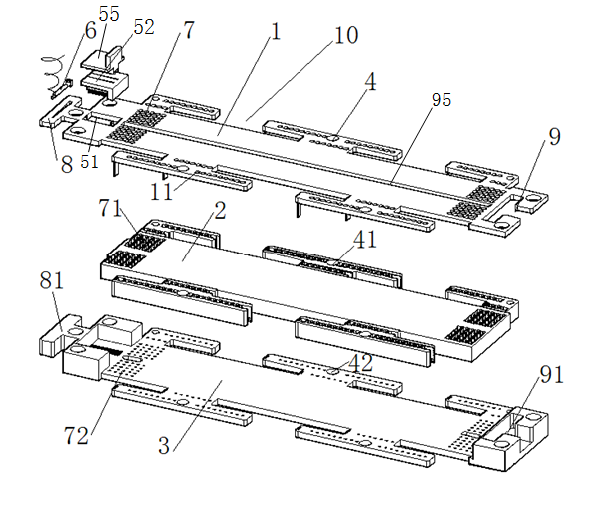

This is the picture of one of the patents I successfully applied. The work is guided by Pro. Wang. For details, please see Pro. Wang’s lab in Lab work item.

Adobe Flash

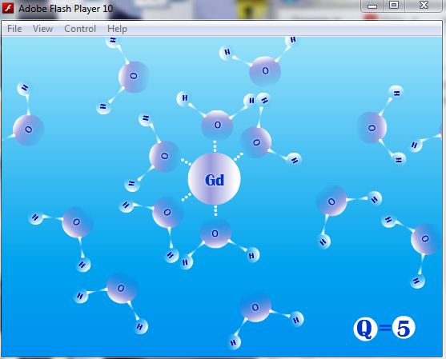

This is one screenshot I made for contrast agents in MRI explanation. For details, please see Pro. Balaji’s lab in Lab work item.

ProE (mechanical software)

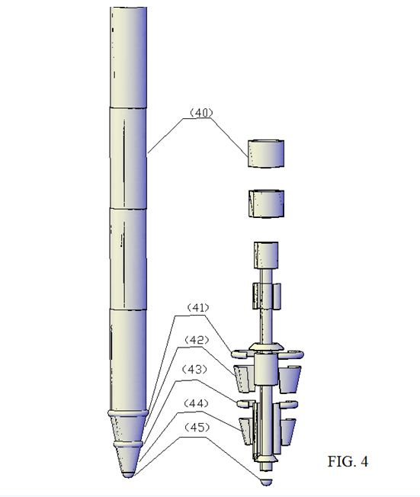

This is one screenshot I made for optogenetic project. For details, please see Pro. Entcheva’s lab in Lab work item.

Adobe Photoshop

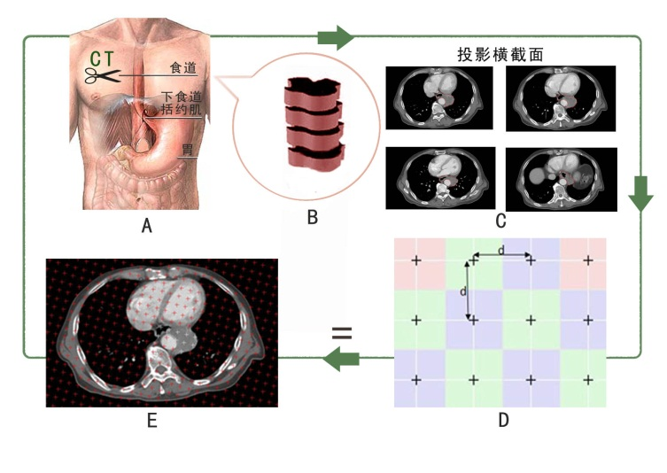

This is one poster I made for the mechanism of CT diagnose for Esophageal cancer. For details, please see Pro. Feng’s lab in Lab work item.

HTML language and Adobe Dreamweaver

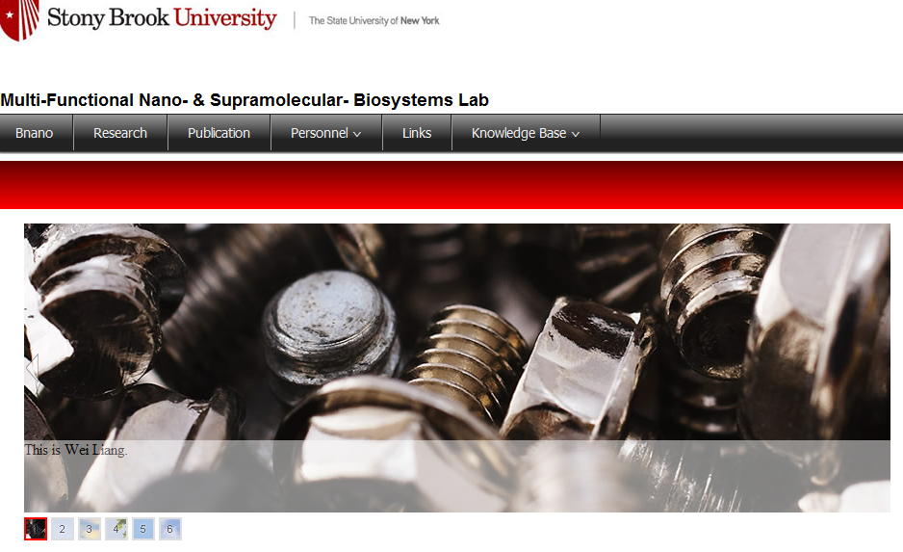

This is one screenshot of the lab website I made for Pro. Balaji. For details, please see Pro. Balaji’s lab in Lab work item.

Labview

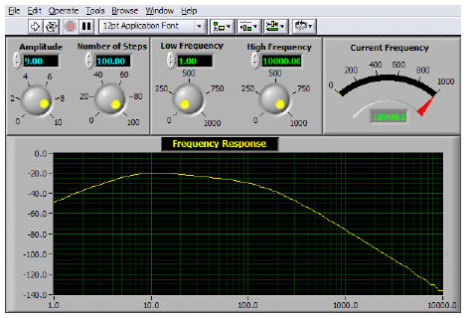

This is one screenshot during my Teaching Assistant course with Pro. Lin in Stonybrook U. This platform is used for the simulation of Bode frequency plot.

Protel (electrical software)

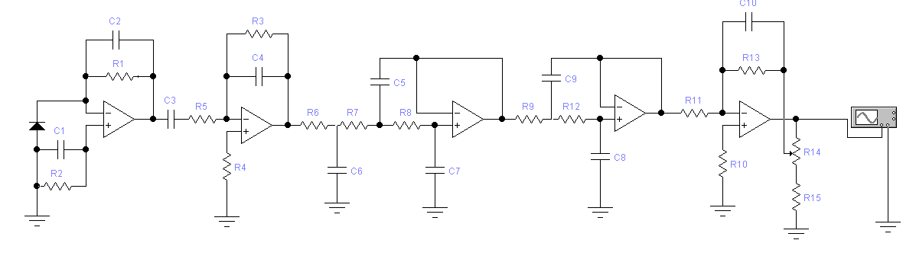

This is the Block diagram for Design of Optoelectronic Pulse Wave Detecting System in Medical Electronics in Pro. Wang’s lab. For details, please see Pro. Wang’s lab in Lab work item.

DNA 2.0(for Gene Synthesis and Design)

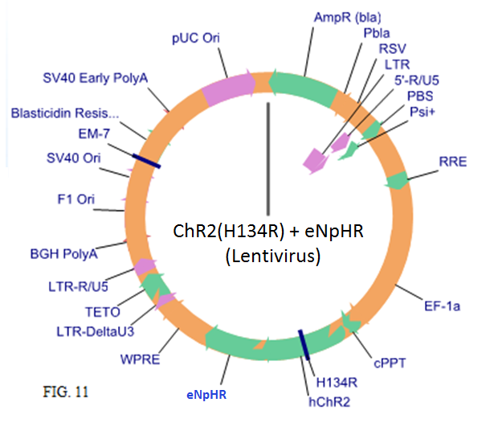

This is the virus design for optogenetics in Pro. Entcheva’s lab. For details, please see Pro. Entcheva’s lab in Lab work item.

Others

(C++, office, Visual Basic,Endnote, etc. )

